Muhammad Ahtisham

Leap SSO implementation

SSO Integration Between 10g and Leap Applications Using Leap Identity Provider
This document outlines the steps necessary to implement Single Sign-On (SSO) between the 10g and Leap applications. This integration will facilitate a seamless user experience when launching the Leap application.

Workflow Overview
10g Application:
1. Token Request:
- The 10g application will request an access token from the CureMD Authorization Portal on behalf of the logged-in user. A sample request for this process is provided below.

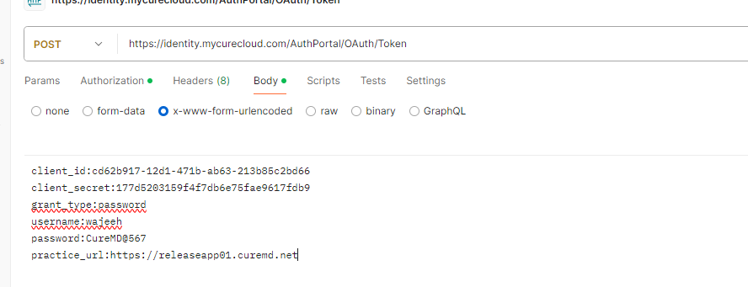

2. Token Exchange:
- Upon receiving the token, the 10g application will initiate a token exchange request with Leap Identity Provider to obtain a Leap Identity Provider token. This Leap Identity Provider token will then be passed to the Leap application during its launch.

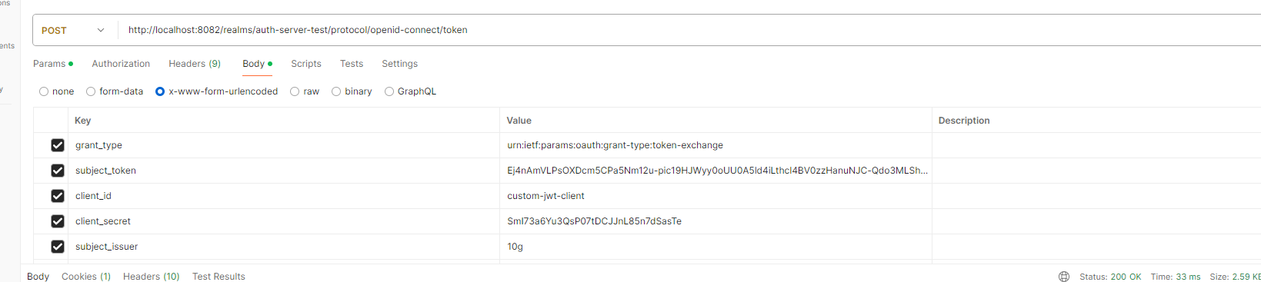

3. Configuration Requirements:
- Along with other configurations, `subject_issuer` which is the ID configured in Leap Identity Provider for the token exchange request, should be made configurable in the application's codebase.

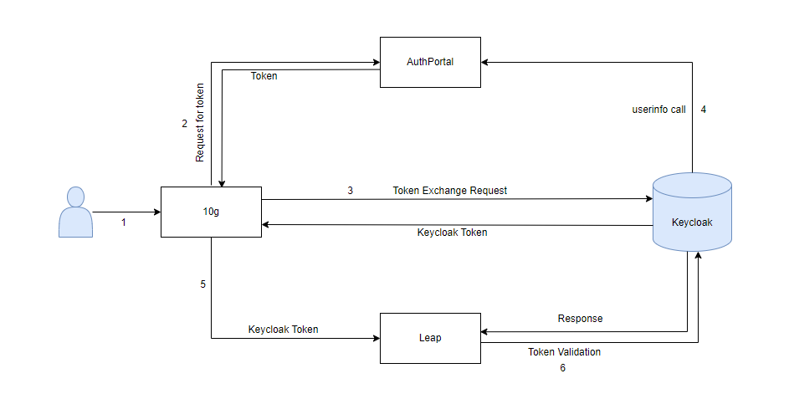

AuthPortal Userinfo Endpoint:
The `userinfo` endpoint in the CureMD Authorization Portal should include the following attributes to ensure the proper identification of users with the endpoint method type as “GET”.
We are expecting providerId in one of UserId when user is provider.
{
"sub": "wajeeh@curemd.com", // should be the email, not the username
"practiceapiurl": "https://releaseapp01.curemd.net/api",
"ProviderId": "1780",
"PracticeId": 1,
"UserId": 15562,
"UserName": "wajeeh@curemd.com",
"ElectronicClaimId": "CMDM2",
"given_name": "Wajeen",
"family_name": "Rehman"
}

Leap Identity Provider Configuration
To achieve seamless SSO integration between the 10g and Leap applications, the following configurations are required in Leap Identity Provider:
1. Enable Token Exchange Feature:
- Set the environment variable `KC_FEATURES=token-exchange,admin-fine-grained-authz`.
2. Client-Level Token Exchange Permissions:
- Enable token exchange permissions at the client level.
- Create an exchange policy specific to the client.
3. External OIDC Identity Provider Configuration:
- Configure the CureMD Authorization Portal as an external OIDC Identity Provider (IDP) within Leap Identity Provider.
- Define an alias to be used by the 10g application in the token exchange request.
- Specify the Authorization Token and User Info endpoints for the external IDP.
4. Realm-Level Configuration:
- After saving the client configurations, enable token exchange permissions at the realm level.
- Define and apply the policy created for the client.
Client-Level Permissions and Policies:
Ensure that the client has the necessary permissions and policies configured for token exchange. This includes:
- Configuring client policies to regulate token exchange.
- Ensuring that the IDP configurations are correctly set up to communicate with the external Authorization Portal.
Identity Provider (IDP) Configuration:
The following configurations should be applied to the IDP within Leap Identity Provider to facilitate the SSO integration:
- Define an alias for the external IDP.
- Set up the required endpoints (Authorization Token and User Info).
- Apply the necessary permissions and policies at both the client and realm levels.

Visual Configurations:
Several configurations related to client and realm-level permissions, as well as IDP setup, are visually represented in the attached images.
